Troubleshooting Guide



**Troubleshoot Calendar and Delegate issues**

Contents

1. Calendar/Delegate permission Issue 3

2. Add/Remove Delegates from Outlook/OWA 4

3. EA/MD Issues…………… 7

4. Common Meeting invite errors 8

5. Duplicate Meetings 13

6. Calendar timing incorrect 15

# Calendar/Delegate permission Issue

Delegate Access goes beyond just sharing access to your folders. Delegates are granted additional permissions, such as creating email messages or responding to meeting requests on your behalf.

**Change permissions for a delegate**

1. Click the File tab.
2. Click Account Settings, and then click Delegate Access.
3. Click the name of the delegate for whom you want to change permissions, and then click Permissions.

*Note:* If you want to remove all Delegate Access permissions, don’t click Permissions but instead click Remove and skip the rest of these steps.

1. Change the permissions for any Outlook folder that the delegate has access to.
2. To send a message to notify the delegate of the changed permissions, select the Automatically send a message to delegate summarizing these permissions check box.

*Note:* If you want copies of meeting requests and responses that you receive to be sent to a delegate, ensure that the delegate is assigned Editor (can read, create, and modify items) permission to your Calendar folder, and then select the Delegate receives copies of meeting-related messages sent to me check box.

**Change delegate access to private items**

If you have assigned permissions to a delegate so that he or she can access your Outlook folders, you can hide personal information in appointments, meetings, tasks, and contacts. Open each personal item, and in the Tags group, click Private.

To grant access to your private items, do the following:

1. Click the File tab.

2. Click Account Settings, and then click Delegate Access.

3. Click the name of the delegate for whom you want to change access to your private appointments, and then click Permissions.

4. Select the Delegate can see my private items check box.

# Add/Remove Delegates from Outlook/OWA

Delegate Access goes beyond just sharing access to your folders. Delegates are granted additional permissions, such as creating email messages or responding to meeting requests on your behalf.

**How to add delegates from Outlook.**

A delegate automatically receives Send on Behalf permissions. By default, the delegate can read only your meeting requests and responses. The delegate isn’t granted permission to read other messages in your Inbox.

1. Click the File tab.
2. Click Account Settings, and then click Delegate Access.
3. Click Add.
   1. If Add doesn’t appear, an active connection might not exist between Outlook and Exchange. The Outlook status bar displays the connection status.
4. Type the name of the person whom you want to designate as your delegate, or search for and then click the name in the search results list.

*Note:* The delegate must be a person in your organization's Exchange Global Address List (GAL).

1. Click Add, and then click OK.
2. In the Delegate Permissions dialog box, accept the default permission settings or select custom access levels for Exchange folders.

If a delegate needs permission to work only with meeting requests and responses, the default permission settings, such as Delegate receives copies of meeting-related messages sent to me, are sufficient. You can leave the Inbox permission setting at None. Meeting requests and responses will go directly to the delegate's Inbox.

1. To send a message to notify the delegate of the changed permissions, select the Automatically send a message to delegate summarizing these permissions check box.
2. If you want, select the Delegate can see my private items check box.

*Important:* This setting affects all Exchange folders. This includes all Mail, Contacts, Calendar, Tasks, Notes, and Journal folders. There is no way to grant access to private items in only specified folders.

1. Click OK.

*Notes:*

* Messages sent with Send on Behalf permissions include both the delegate's and your names next to From. When a message is sent with Send As permissions, only your name appears.
* Once you add someone as a delegate, they can add your Exchange mailbox to their Outlook profile. For instructions, see Manage another person's mail and calendar items.

**How to remove delegates from Outlook.**

1. Open Outlook > File > Account Settings > Account settings > Change > More settings > Advanced > Under "Open these additional mailboxes"
2. You will see your former delegate name added > Remove it and restart your outlook

*Note:* un-mapping a mailbox/Calendar would not remove the permission.

**How to add delegates for Mac.**

Before you can become a delegate, another person must grant you delegate access to a Microsoft Exchange account. You may receive an email notifying you that you have been granted delegate access to someone's calendar, contacts, or email. To access the items for which you are a delegate, you must add the person who granted you access to your People I am a delegate for list. When you want to stop being a delegate for someone, you need to remove the person from the list.

Become a delegate for someone else

*Important:* To become a delegate, you need to have a Microsoft Exchange account.

1. On the Tools menu, select Accounts.
2. Select the Exchange account that you will use to access the delegated items, select Advanced, and then select Delegates.
3. Under People I am a delegate for, select Add.
4. Type the name of the person who added you as a delegate.
5. Select the person's name in the search results, and then select Add.

**How to remove delegates for Mac.**

1. On the Tools menu, select Accounts.
2. Select the Exchange account that you want to change, select Advanced, and then select the Delegates tab.
3. Under People I am a delegate for, select the person for whom you want to stop being a delegate, and then select Remove.

**How to add delegates from OWA.**

1. Open OWA through <https://myemail.accenture.com>
2. Right-click on the Inbox item, located on the left side of the screen, then click “Permission…”
3. Click Add (+)

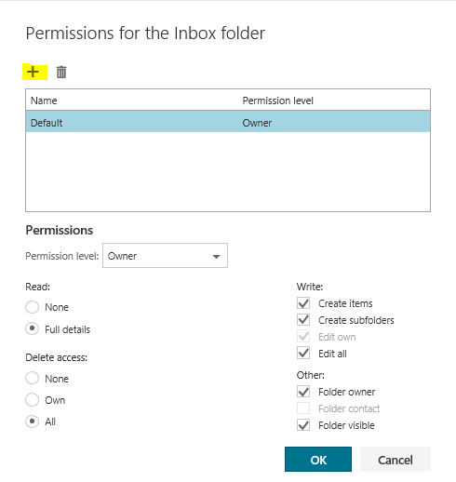

1. Input delegate name.

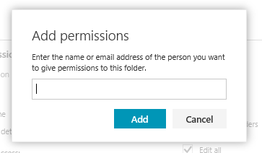

1. After adding the user as delegate, manage the user’s delegate permission.

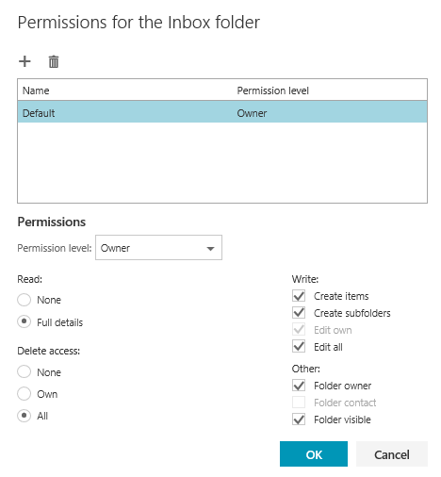

**How to remove delegates from OWA.**

1. Open OWA through <https://myemail.accenture.com>
2. Right-click on the Inbox item, located on the left side of the screen, then click “Permission…”
3. Choose the name of the delegate then click delete.

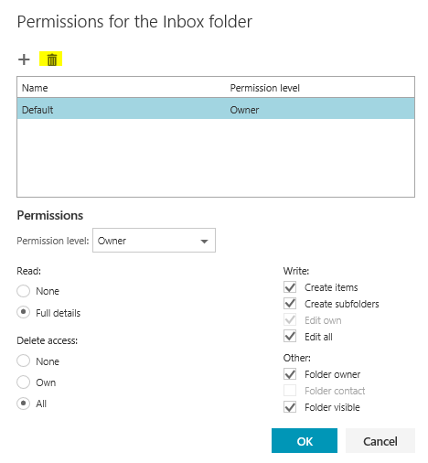

If the issue persists, please contact M&C team (MSGCOLLAB-O365-OPER)

# EA/MD Issues

This is issue is about MD’s giving delegate access to their EA but unable to access their folders.

**EA unable to access MD’s folder upon giving delegate permission**.

**Steps to fix the issue:**

1. Make sure that correct permission is given to the EA.

**Reviewer** - With this permission, the delegate can read items in your folders.

**Author** - With this permission, the delegate can read and create items, and change and delete items that he or she creates. For example, a delegate can create task requests and meeting requests directly in your Task or Calendar folder and then send the item on your behalf.

**Editor** - With this permission, the delegate can do everything that an Author has permission to do and additionally can change and delete the items that you created.

2. Advise MD to remove/re-add the permission.

**EA unable to Send on behalf of MD after giving delegate permission**

**Steps to fix the Issue**

* Advise MD to remove/re-add the permission.

If the issue persists, please contact M&C team (MSGCOLLAB-O365-OPER)

# Common Meeting invite errors

You need to know how to troubleshoot Outlook to fix issues such as calendar appointments not showing up; partial or incorrect information appearing on meeting invitations; meeting requests being sent, accepted, or declined in an endless loop; and many others.

**Meeting creation: attendee not found** - One of the steps for setting up a meeting on the Outlook calendar requires you to specify the meeting attendees.

During this process, some users experience problems with finding a particular attendee on the global address list or loading them up for the meeting.

**Steps to fix the issue**

1. In Outlook, click on File, select Account Settings, and then choose Download Address Book.

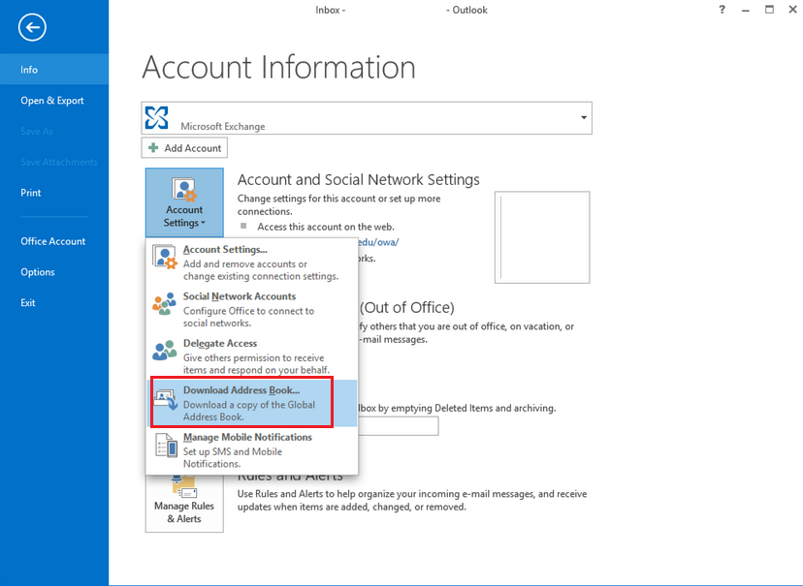

**Free/Busy doesn’t work: no info appears**

**Steps to fix the issue**

The Outlook calendar comes with an excellent feature called Scheduling Assistant, also known as Free/Busy. It basically lets you know if the person you’d like to send an invitation to is already busy or unavailable for your selected date/time range.

To open this feature, simply navigate to the Meeting tab, and click on Scheduling Assistant:

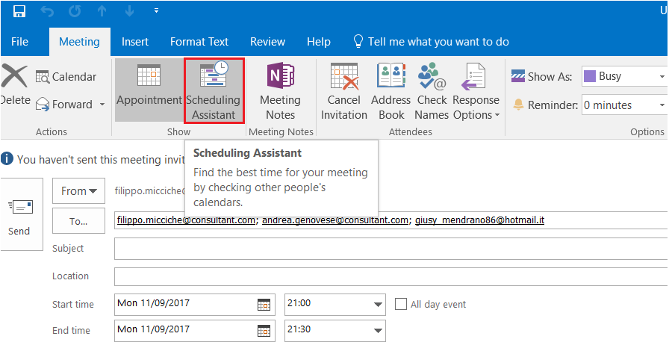

The color legend at the bottom is a good reference for the formatting on screen.

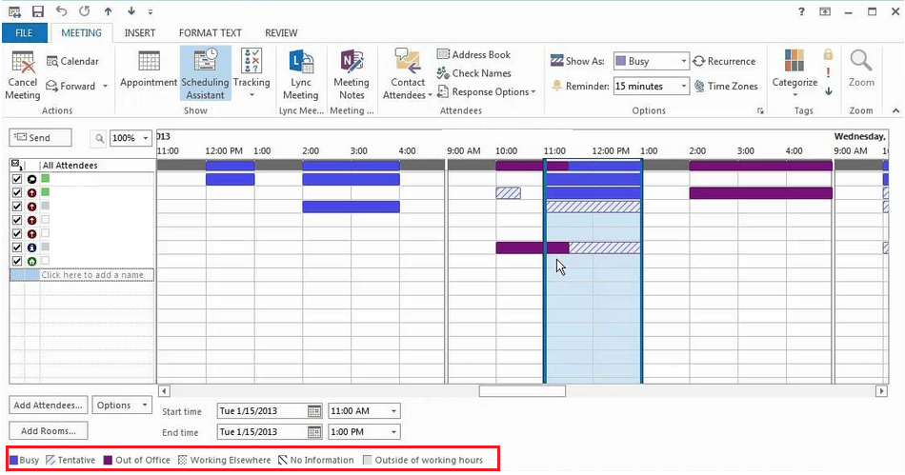

Sometimes, the Scheduling Assistant may refuse to provide you with information about an attendee’s availability.

When this happens, cells will be filled with diagonally striped lines like the ones below:

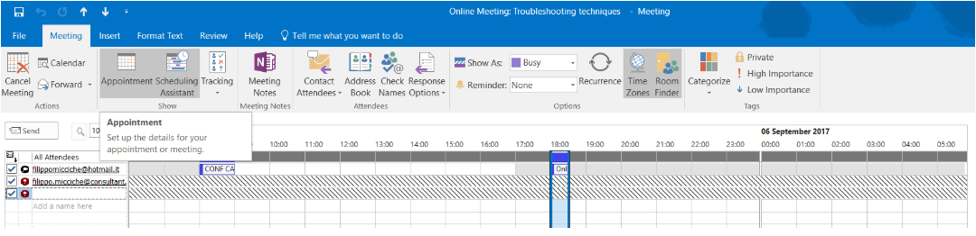

This issue can usually be fixed by following these steps:

1. Run **“Outlook.exe /cleanroamedprefs” (type run command and paste the switch)**
2. The command switch Outlook.exe /Cleanfreebusy restores Free/Busy data. This switch can only be used when Outlook is online.
   1. Refresh the Outlook Address Book (OAB)
3. In Outlook, click on File, select Account Settings, and then choose Download Address Book.
4. Check in OWA(webmail) as well if the issue persists. If it does not persist in OWA then please check by recreating profile, it may be a local issue.

**ELSE:**

It can be a situation where in the recipient with whom you are trying to schedule the invite has chosen to hide his free busy info.

**How to check this?**

1. Right click on the recipient calendar and check how he chose to publish the information, under permission tab
2. The recipient will have the settings like below

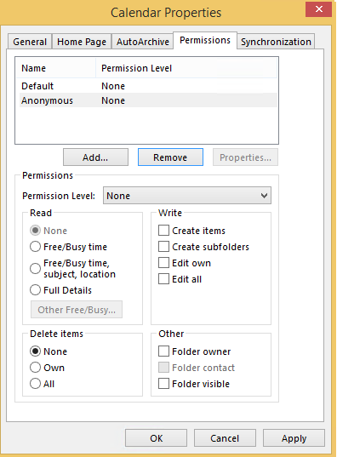

1. Request the Recipient to correct to default settings like below

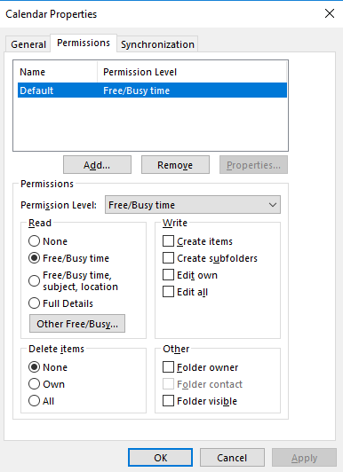

If the issue persists, please contact M&C team (MSGCOLLAB-O365-OPER)

**Outlook meetings disappearing Tools**

If you’re unable to see the meeting invitation you just sent on your Outlook calendar, follow these steps to resolve the problem:

1. Run **“Outlook.exe /cleanroamedprefs”**
2. This switch command cleans (and copies again) your Outlook roaming preferences from the local settings of the PC on which it is run.
3. Roaming settings are a small collection of settings that govern reminders, the Free/Busy grid, working hours, calendar publishing, and RSS rules.
4. Settings running on Exchange Server can change during an Outlook session. Normally, as soon as new settings become available, they are updated for the user client. Unfortunately, in certain cases, this doesn’t happen, leading to various problems. Running Outlook.exe /cleanroamedprefs should fix the problem.
5. To do so, click on Start. In the search box, type Outlook.exe /cleanroamedprefs, and hit enter. (Note: there is a space after “.exe” and before the forward slash).
6. Outlook should start up again.

* Run **“Outlook.exe /sniff”**

1. The switch command Outlook.exe /sniff overrides the programmatic lockout that defines which client is processing the meeting item.
2. It will open Outlook, look for new meeting requests in the inbox, and add them to the calendar.
3. Click on Start. In the search box, type Outlook.exe /sniff, and hit enter.
4. Run **“Outlook.exe /cleanprofile”**
5. This command removes invalid profile keys and rebuilds default registry keys, as needed.
6. Click on Start. In the search box, type Outlook.exe /cleanprofile, and hit enter.
7. **Check if the meeting is visible on the cloud calendar of the Outlook Web App**
8. The Outlook Web App (OWA) is the Microsoft Exchange web-based email client. The user interface is like that of Microsoft Outlook, but the web-based version doesn’t require the client software (Outlook) to run on your PC.
9. Login to OWA.
10. Then, navigate to the Calendar.

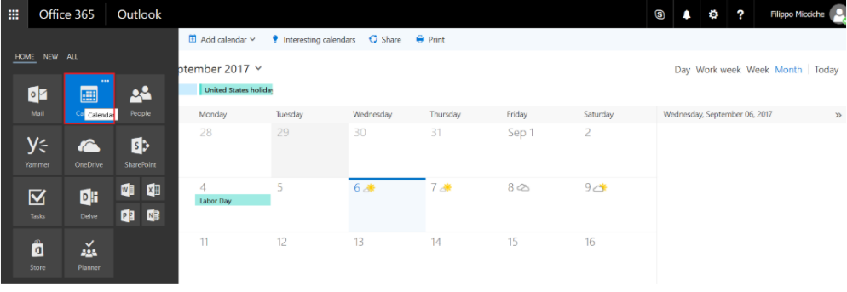

**The meeting is not present on the OWA calendar:**

* If the meeting is not present on the OWA calendar, the best thing you can do is contact M&C team (MSGCOLLAB-O365-OPER)

**The meeting is present on the OWA calendar**

**Create a new Outlook profile, and check if the meeting invitation is visible on the new profile calendar.**

1. Close Outlook.
2. Go to Start, and navigate to the Control Panel. Click on Mail.
3. The Mail Setup window will pop up.
4. Click on Show Profiles.
5. Click on the Add button.
6. Choose the name for the new profile, and click OK.
7. The Autodiscover service should be able to create the Outlook profile automatically.
8. Click Next and then Finish.
9. Revisit the Mail Configuration window, and select the option that reads “Always use this profile”

If the issue persists, please contact M&C team (MSGCOLLAB-O365-OPER)

# Duplicate Meetings

Several users have noted the issue where Outlook Calendar will repeatedly send the same meeting invitation to attendees, even if they’ve already confirmed their times.

This is most often (but not always) caused by external device protocols that communicate with Exchange Server. In fact, if the meeting organizer or one or more attendees are synchronizing their calendars on their smartphones, the synchronization is typically handled by a network protocol developed by Microsoft called Exchange ActiveSync.

In such cases, the calendar tends to misbehave.

* + - 1. Run “Outlook.exe /Cleanreminders”

1. This switch command clears and regenerates calendar reminders.
2. Click on Start. In the search box, type Outlook.exe /Cleanreminders, and hit enter.
3. Restart Outlook, and check if the issue persists.
   * + 1. Delete the meetings in question
4. The meeting organizer and all attendees must delete the meeting.
5. It will be necessary to remove the meeting from:
6. The Outlook client software
7. The Mail application synchronizing your mailbox to the external device
8. The Outlook Web App calendar
9. Then, the meeting will need to be recreated. Right-click on the meeting invitation,and select Cancel Meeting.

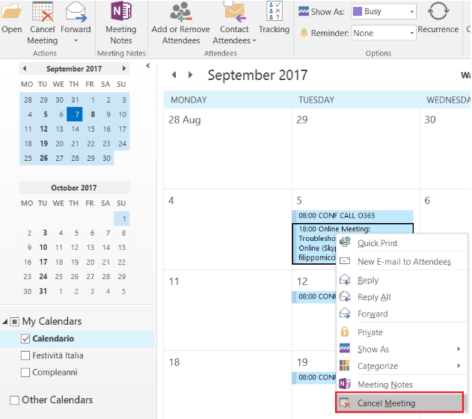

* + - 1. Log out from the Mail application on the external device

If the issue persists, the meeting organizer or attendees will need to temporarily log out from the email applications installed on their devices. This will help narrow down the possible root causes to determine whether the problem is caused by Exchange ActiveSync.

Most likely, the issue will disappear once you log out of the mobile email application.

After deleting and recreating the meeting, try synchronizing the mobile email application calendar one more time to see if things work properly.

If the issue persists, please contact M&C team (MSGCOLLAB-O365-OPER)

# Calendar timing incorrect

Outlook is not showing correct time for meetings and appointments can be caused by the time zone setting of the machine/laptop where the application is dependent on as well as on the Daylight-Saving Time.

**Steps to fix the issue**

Kindly seek assistance to LTS/Workstation Support on performing below steps.

1. Checking setting on Windows
   1. On Control Panel, Go to **Time and Date**.

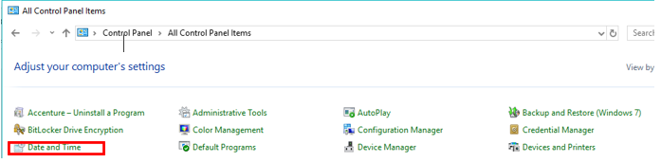

* 1. In the **Time Zone** section, make sure that the time zone and Daylight Savings Time settings are correct for your region.

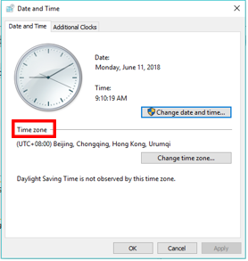

1. Checking setting in Outlook.
   * Go to **File > Options > Calendar**. Make sure that **Time Zone** setting is the same as in the Windows Date and Time control panel.

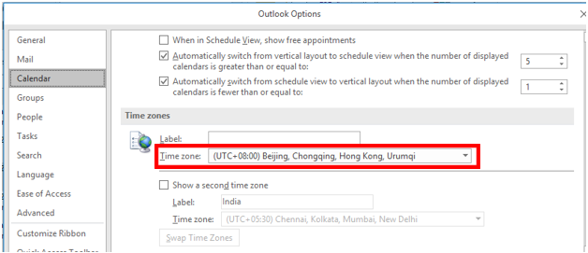

1. Checking setting in OWA
   * Access <https://myemail.accenture.com> and Go to Options by clicking the Gear Icon Under **General** > **Region and time zone**. Verify the settings for **Current time zone.**

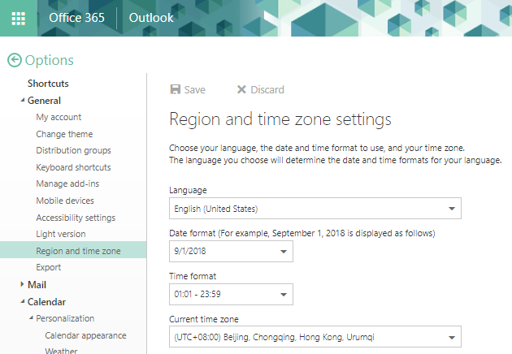

1. There are instances wherein Daylight-Saving Time is already over, time on meetings and appointments are still not displaying correctly. What user needs to do is just update Office. In Outlook, go to **File > Office Account** and from there, user can perform the update.

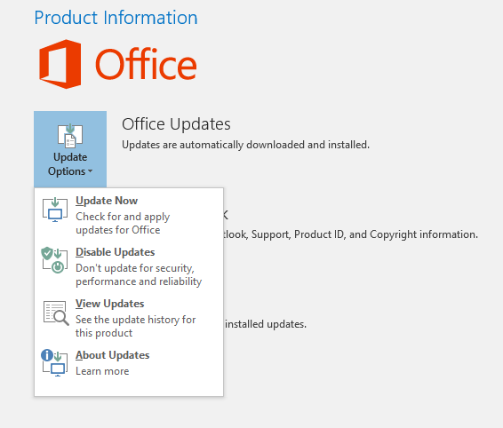

If the issue persists, please contact M&C team (MSGCOLLAB-O365-OPER)